**High Concept Document**

**Tyrin Stocken**

**High Concept Statement:**

This is a top down RTS game were there are two factions fighting to be victories in a simulation of a 20x20 game world. The aim of the RTS game is to kill all the cursed units on the map. My game world is based in medieval times and my units are made up of a Knights and archers (normal and cursed variants of both). There are also two buildings that assist their faction by spawning more units and generating resources for the faction.

**Game Treatment:**

This game is RTS top down simulation of a battle between two teams. The game is unique because of how different the lore of the game is and how interesting the different classes are and feel.

**Character Design:**

The characters in my game are based on medieval knights and archers. The knights are in full metal armor with a leather and steel shield and a steel broadsword. The archers use a maple longbow and had a small steel dagger if the enemy got to the appropriate range to use it.

Features:

Knight

* Tall
* Large body shape
* Strong
* High defensive level
* Slow
* Close range combat only

Archer:

* Short
* Small body shape
* Average strength
* Low defensive level
* Fast
* Long range combat mainly (Capable of close range combat)

**World Design:**

The world is in medieval times and the buildings and architecture is primitive and mainly stone based. The landscape is filled with hillsides and mountainous zones, the main battlefields are fields of long grass with rivers running in and around them. The land has been partially cursed and the cursed kingdoms have been overrun by demons that have taken control of everyone in the kingdom (now known as the cursed). These possessed warriors are trying to take over. This is were the other kingdoms are planning to attack the cursed to try get rid of them and get the kingdoms back to how they were before all the chaos.

**Flow board:**

Run the program

Start the simulation

Pause the simulation

Save the data

Continue the simulation

Wait till a team wins a team to won

Close the program

**Story and Level Progression:**

The story of my game is the two factions are based on two different kingdoms that are attacking each other. One cursed kingdom and one normal kingdom. The level progression is linear and is based on how fast the units kill each other. The faster they units kill each other the faster the simulation will be done.

**Game Script:**

This is a sample of the game script please refer to the repository link below to see the rest of the game code in the task 3.

using System;

using System.Collections.Generic;

using System.Linq;

using System.Text;

using System.Threading.Tasks;

using System.IO;

using System.Diagnostics;

namespace GadeTask17607849

{

class ResourceBuilding : Building

{

protected int xPosition;

protected int yPosition;

protected int health;

protected string faction;

protected string symbol;

protected string resourceType;

protected int resourcesPGT;

protected int resourcesRemaining;

public int Resources = 0;

public ResourceBuilding()

{

xPosition = 19;

yPosition = 0;

health = 100;

faction = "P";

if (Resources >= 50)

{

symbol = ".";

}

else

{

symbol = "%";

}

}

public ResourceBuilding(int xPosition, int yPosition, int health, string faction, string symbol, string resourceType, int resourcesPGT, int resourcesRemaining)

: base(xPosition, yPosition, health, faction, symbol)

{

this.resourceType = resourceType;

this.resourcesPGT = resourcesPGT;

this.resourcesRemaining = resourcesRemaining;

}

override public bool isActive()

{

if (Health < 1)

{

return false;

}

else

{

return true;

}

}

override public string toString()

{

string output = Convert.ToString(xPosition);

output += Convert.ToString(yPosition);

output += Convert.ToString(health);

output += faction;

output += symbol;

return output;

}

public override void save()

{

FileStream outFile = null;

StreamWriter writer = null;

try

{

outFile = new FileStream(@"Files\resourceBuilding.txt", FileMode.Create, FileAccess.Write);

writer = new StreamWriter(outFile);

writer.WriteLine(xPosition);

writer.WriteLine(yPosition);

writer.WriteLine(health);

writer.WriteLine(faction);

writer.WriteLine(symbol);

}

catch (Exception fe)

{

Debug.WriteLine(fe.Message);

}

finally

{

if (outFile != null)

{

writer.Close();

outFile.Close();

}

}

}

public void generateResources(int tic)

{

Resources += 10;

resourcesRemaining -= 10;

}

}

}

**User Interface:**

Features:

There is a timer in the top left of the UI.

Map on the right side of the UI.

Four buttons for user to control the simulation at the bottom of the UI.

Lastly there is a textbox on the left hand side to display information to the user.

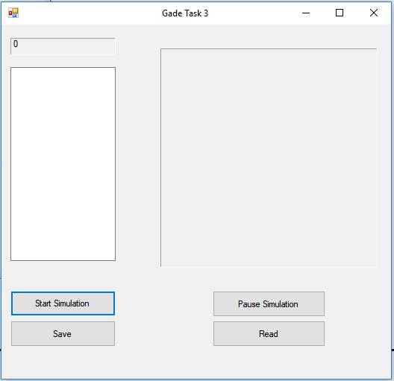

**Repository Link:**

<https://github.com/TyrinStocken/GADE6112-Tasks>